|  |  |  |
| --- | --- | --- |
| Correo Digi | February 10  2014 | |
| This document includes technical specifications for the first iteration of CorreoDigi. CorreoDigi is a web-based application that aims to create a simple interface for sending digital letters between connected users. | | EWB-SMU piLab team |

CorreoDigi

## EWB-SMU piLab Team Members

Ashley Isles

Aurora Havens

Austin Wells

Brandon Guerra

Carly Kubacak, Junior CS

Conrad Appel IV

Edward Li

Emely Villeda-Principe

Gwen Caris

JD Francis

Morgan Monzingo

Olivia Schmid

Patrick Leopard II

Viral Kotecha

Yassi Shaba

## Executive Summary:

The EWB-SMU piLab team is working to set up a raspberry-pi-powered computer lab in an Orphanage in Honduras. Our goal in creating the piLab is to open up communication between the children in Honduras and the people who visit the orphanage and then return to the United States. Through the piLab project, we aim to create an efficient and customizable method of establishing pi-powered computer labs in undeveloped parts of the world.

To address the communication problem in the orphanage in Honduras, the piLab team will develop a custom, web-based application, CorreoDigi, that the children in Honduras can use to communicate with their friends in the United States. CorreoDigi will simulate traditional, letter-writing correspondence. To ensure that all parties can understand the application, we will design simple user interfaces in both English and Spanish.

Once development of CorreoDigi is completed, the EWB-SMU piLab team will travel to Honduras and set up the piLab. During this time, we will teach the children how to use the application and gather information about how to improve CorreoDigi and what other software applications might be of interest to the children in the orphanage. We currently have plans to create gardening software as well as expanding CorreoDigi to include mentorship components.

**Product Specifications page needs to include:**

* ~~Software functionality~~
* Use case diagram (high level—summarizes software functionality)
* ~~Activity diagrams for each “functionality” (specify paths for different user roles)~~

# Product Specifications

## Software functionality:

**Visitors can**

1. Register
2. Register as Mentor
3. Register as Teacher
4. Read about <product name>

**Mentees can**

1. Login
2. Request Password Reset
3. Send a Letter
4. Save a Draft
5. Read a Letter
6. Delete a Letter
7. Flag a Letter
8. Delete Account
9. Edit Account Info
10. Search Users
11. Add a Contact
12. Manage Contact requests
13. Flag a Contact
14. Delete a Contact

**Mentors are Mentees that can**

1. Reset password by email

**Teachers are Mentees that can**

1. Reset password with security questions
2. Reset passwords for mentees

**Administrators are Teachers that can**

1. Review flagged letters
2. Review flagged users
3. Suspend a user
4. Grant Admin Status

## Register.pngRegister

## ForgotPassword.pngPassword Reset

## OpenLetters.pngManage Letters

<http://yuml.me/edit/f0ca8316>

## Manage Contacts

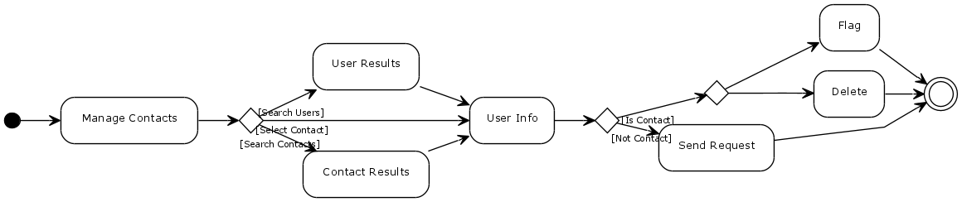<http://yuml.me/edit/9bd105ac>

## Manage Contact Requests

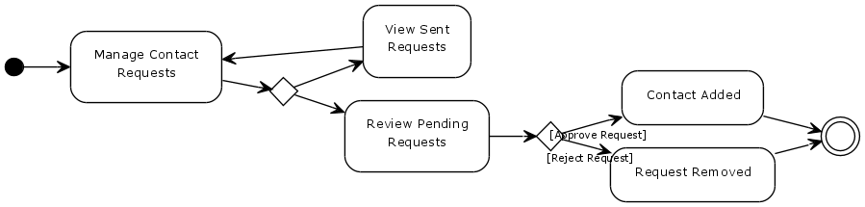<http://yuml.me/edit/f7dd5505>

## Review Flagged Users and Letters

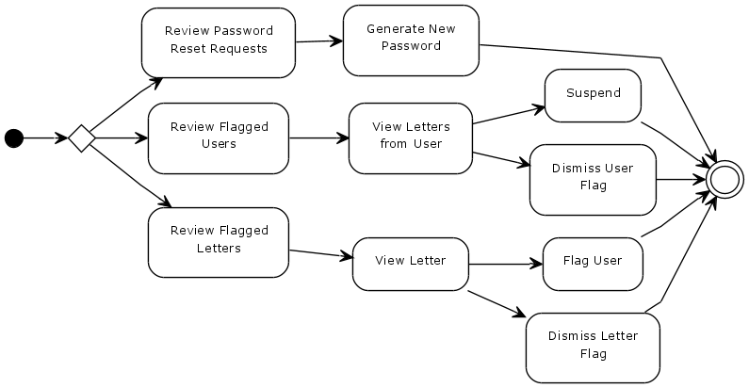<http://yuml.me/edit/ba1a4ca5>

**UI Structure page needs to include:**

* Object Action matrix
* Design choices (colors, fonts, logos)
* Wire frames that outline core pages (login, register, home page, add contact, send letter, etc.)

# UI Structure

**Database Design page needs to include:**

* Conceptual Database model
* Schema for each page (table format)

# Database Design